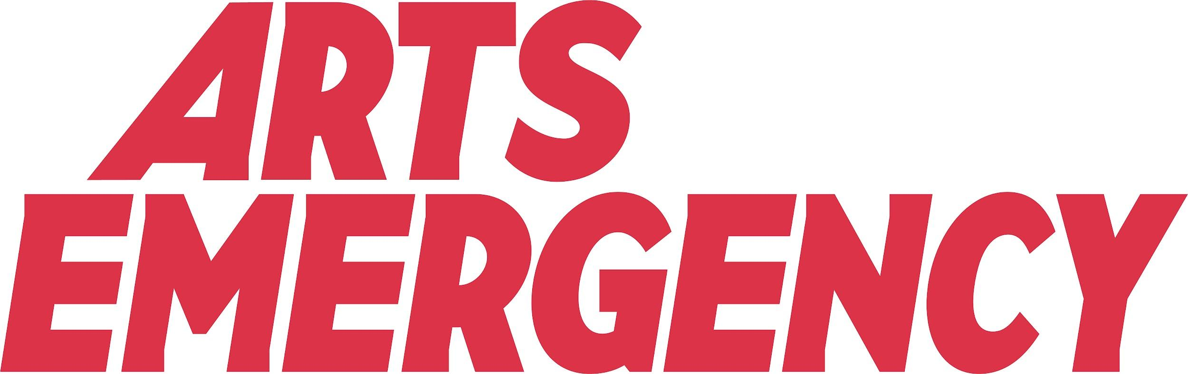

Template: Risk assessment

This document is designed to be used to assess health and safety hazards associated with a young person on an online work placement. Please return this assessment prior to the placement taking place.

In order to complete this assessment successfully, you can refer first to the following Health and Safety Executive guidance:

The Right Start. Work experience for young people: http://www.hse.gov.uk/pubns/indg364.pdf
Five steps to risk assessment: http://www.hse.gov.uk/pubns/indg163.pdf

Please outline the background information and confirm it is correct

Job role: | Arts Emergency Work Experience Placement
Location of job role: | Online
Signature (person carrying out risk assessment)
Signature: (person acting as supervisor of young person - if different to the person above)

HAZARD | DESCRIPTION | RISK OF INJURY OR EXPOSURE | ACTION / COMMENTS
Psychological capacity | Are there tasks, which rely on skill, experience and an understanding that the young person might not have?  You should provide young people with training and effective supervision, particularly where they might:  - Benefit from additional training, especially skills or tasks that would be easier to learn or understand in an in person environment.  - Use new programmes that they may be unfamiliar with.  - Be potentially exposed to violent or aggressive behaviour or materials that are inappropriate or traumatic in nature.  - Meet adults who have not committed to Arts Emergency’s code of conduct, who might pose a safeguarding risk to a young person.
Display Screen Equipment | Correct posture is very important to prevent undue strain being placed on the neck, shoulders, back, arms and wrists.  Ensure that a VDU workstation assessment is carried out. You can download a free PDF on the HSE website.  Using Display Screen Equipment for long hours can lead to headaches and migraines. Ensure that you are offering regular breaks during the working day.

INTOLERABLE RISK (High Risk) – Remove hazard immediately
SUBSTANTIAL RISK (Medium Risk) – Adapt working practices & introduce control measures
MODERATE RISK (Low Risk) – Advise & supervise Young Person

