Work Experience Guidance

Thank you for offering a young person work experience! Struggling to find quality work experience opportunities puts our young people at further disadvantage in comparison to their more privileged peers. Spending time with your organisation will help them to feel more confident, more connected and more knowledgeable. This guide is designed to support you and your colleagues through every step of the placement. Click on the titles below to go to each section.

- Information about Arts Emergency
- Information about work experience: What’s required from you and your organisation
- Tips for online work experience
- Tips for hybrid work experience: If you are doing a combination of online and on-site work experience
- Examples of work experience tasks
- The week before the placement: Things to do before your first day
- On the first day: Things to cover in your first conversation
- During the week: Things to do during the placement
- On the last day: Things to cover in your final conversation
- Feedback from previous placements
- Reporting
- Safeguarding advice: Keeping our young people safe, social media and photography
- Important Links

Information about Arts Emergency

Arts Emergency is an award-winning charity founded by comedian Josie Long and activist Neil Griffiths. Since 2013 we have provided expert mentors, guidance and opportunities to support hundreds of young people into higher education and creative careers.

For our society to be fair and kind, every young person should have the chance to contribute to the culture they live in. That’s why Arts Emergency is dedicated to levelling the playing field. Our holistic programme opens up opportunities in higher education, media and the arts to underrepresented young people, and our aim is to change the make-up of who creates culture. Our community of over 7,000 writers, thinkers, artists, performers, media professionals, academics, and activists is united by this cause. We’re working together towards a more just, representative and vibrant cultural future.

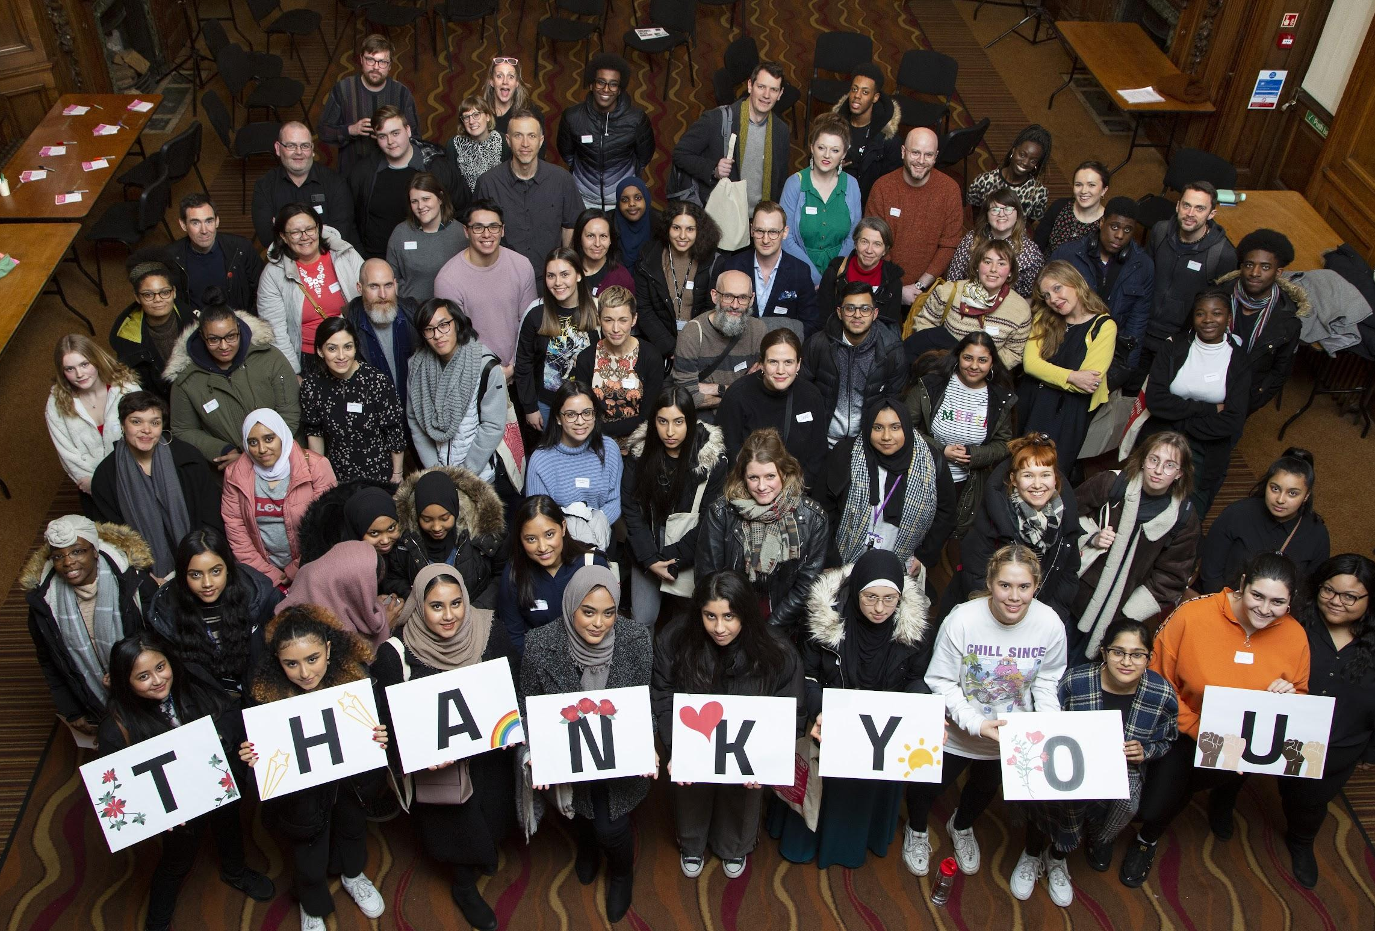
Young People at our Celebration Event. Credit Lilla Nyeki

Information about work experience

You will support a young person on a work experience placement for five working days. If you want the young person to join you for longer than a week they must be paid the Living Wage in your area. If this is something you are considering, please get in touch with Arts Emergency first for advice.

A work placement should be a chance for young people to experience what a normal week in your industry is like. For some of our young people, this will be their first experience in a work or office environment. Do not expect them to be familiar with your industry, technical language and jargon, or computer software. You shouldn’t be giving them work that requires a lot of existing knowledge but instead varied tasks and challenges they’ll learn from.

On-site placements must only be in Manchester, Merseyside, Brighton and London where the majority of our young people are based.

On-site work experience will only go ahead if government Covid-19 guidelines allow. You must prove that you have Covid-19 guidelines in place to ensure the safety of our young people and your staff.

If you are an organisation, you can offer a hybrid online/ on-site placement. You must follow the guidance for both online and on-site work placements below.

What is required?

 | Online Work Experience | On-site Work Experience | Hybrid Work Experience
Who can provide work experience? | Freelancers and organisations welcome | Organisations only | Organisations only
Specific dates for running your placement? | Five working days between  25 - 29 July or  22 - 26 August | 25 July to 2 September
If it’s longer than 5 days, what happens? | You must pay at least the Living Wage for your area
Do I provide a lead contact? | Yes
What risk assessment do I need to give? | An online risk assessment | An on-site and Covid-19 specific risk assessment | An on-site, online, and Covid-19 specific risk assessment
Do I provide lunch and travel expenses? | No | Yes - we recommend £15 a day.
Employers Liability Insurance Certificate? | No | Yes | Yes
Do I need to read and sign the Code of Conduct? | Yes
Do I need to read our safeguarding guidance? | Yes - including online safeguarding guidance | Yes | Yes - including online safeguarding guidance
Attend an online briefing on day one? | Yes | No | No

The role of the lead contact

As the lead contact, we will ask you to:

- be the trusted and friendly contact for our young person during the placement
- read and sign our Code of Conduct
- read our safeguarding procedures if you are working with someone under 18
- have a short, informal interview with the young people ahead of the placement
- create a variety of tasks (written, creative, administrative) that can be completed within five days
- do an in-person, phone or video check-in call with the young people you are supporting every day
- fill in a short report at the end of the placement
- be on all phone/video calls and in-person meetings with a young person under 18 and other members of your team
- be cc’d into all emails with a young person under 18 and other members of your team
- for online placements, you must attend an online briefing on the first day of the placement
- ensure the safety of our young people during the placement
- make sure there is a back up contact in case you are unavailable due to unforeseen circumstances. If this happens, please inform Arts Emergency as soon as possible

Tips for Online Work Experience

Online work placements are an excellent way for young people to experience what remote working is like. It’s an especially good experience into what being a freelancer in the creative or cultural industries is like. We ran 36 remote work experience placements in 2021 and are here to help with any questions you might have. Get in touch!

Software, technology and equipment

Not all our young people will have access to their own computers, laptops, mobiles and other devices. Please bear this in mind when you are planning for a week of online work experience. Think about what equipment is necessary, what offline activities can be organised as a backup and what you can provide in advance of the placement. We will let you know the young person’s digital access needs, if any, in advance. If you would like to send something to the young person before the placement begins, let Arts Emergency know. Do not expect young people to already have access to software.

Online platforms

Please communicate with the young person over video call and email primarily.

If they are unable to do this because of internet access and would prefer to communicate over the phone, please inform Arts Emergency. You are welcome to use any online tool that best works for you and your organisation, except for social media platforms including Facebook, Instagram and Twitter.

TIP: We recommend explaining your chosen online platform to the young person beforehand to see if they are comfortable with it.

TIP: Let the young person know they don’t have to have their video on in video calls if they are not comfortable.

TIP: Explain tasks over video call at the beginning of the day to make sure they have understood and to give them the opportunity to ask questions. Check in with them at the end of the day too.

Here are the online video platforms we recommend:

Platform | Pros | Cons
Google Hangout/ Google Meet | - ability to share screen  - chat function as well as video chat  - free on wifi  - live closed captions available  - young people use this in schools/colleges | - requires a Google account to set up a meeting (not to attend as a guest)  - uses a lot of bandwidth
Zoom | - ability to share screen  - chat function as well as video chat  - high quality and offers break out rooms  - live closed captions available  - secure with passwords and waiting rooms | - only 40 minutes of free call time - will need a paid subscription for any more
Slack | - real-time message function as well as video chat and huddles  - ability to share screen  - free on wifi  - good for project management | - young people will be less familiar with this platform  - live closed captions are unreliable
Teams | - ability to share screen  - chat function as well as video chat  - free on wifi  - live closed captions available | - requires a Microsoft account to set up a meeting (not to attend as a guest)  - uses a lot of bandwidth

Replicating the office environment

The challenge with online work experience is replicating the office atmosphere. There are still lots of ways you can make sure the young person feels part of the team:

- organise informal online ‘getting to know you’ tea breaks with team members (make sure you are present if they are under 18)
- invite the young person to sit in on online meetings so they can experience conversations in different departments
- try to mark the beginning and the end of the week with an online group meeting to welcome them and say goodbye
- post them any literature in advance so they get a better understanding of your organisation (if you want to do this, please contact Arts Emergency).

Tips for Hybrid Work Experience

- we’d recommend having on-site days on your first and last day
- be clear on the first day when the young person will be expected to travel into the office
- ensure the young person knows where your office is located on their first day
- make sure you are covering travel and confirm if you will be paying via BACs, petty cash and if you need the young person to keep receipts
- read through the tips above for online work experience too!

Examples of work experience tasks

Great work experience tasks are varied, informative, challenging and fun. Giving your young person a range of written, creative and administrative tasks that can be completed within five days will make the experience more stimulating. It’s also a good idea to have tasks that are both online and offline.

TIP: We recommend creating a timetable for the week so you can share this with your young person in advance.

TIP: You might want to use Slack, Trello or Google Drive live documents to collaborate with your young person. This is especially useful if their wifi isn’t stable enough for good video calls.

Examples

- ask your young person to write an article, blog post or record a video diary. Here’s one written by a young person during her placement at the Times educational Supplement. Here’s another one written by a young person at Artsadmin. Watch this video diary made for Mountview Theatre Academy
- set your young people a research brief based on an issue your organisation is facing
- give your young person a design project and ask them to present it to your team. Read this example from an Architecture studio
- have your young person take over your social media for the afternoon/day
- if you are a freelancer, you could set practical tasks such as creating a budget or responding to a practice brief.

Example from Curtis Brown talent agency

Day 1 | - Introduction to what an agent does  - General Q&A on Curtis Brown/clients/website etc  - Read a script and provide a synopsis and character breakdown
Day 2 | - Watch a show with Curtis Brown clients in and draft a news story for the company website  - Join two assistant meetings to hear more about the work of an assistant
Day 3 | - Prepare questions for Q&A sessions with talent agents  - Draft tweets for Curtis Brown
Day 4 | Research client press packs then create and present one of your own
Day 5 | Workshop on CV writing incorporating skills learnt over the week

Example from a freelance costume designer

Monday | Researcher Day:  Research 1960s London, make a list in Word of organisations and websites you could use for research
Tuesday | Assistant Designer Day:  Make a mood board
Wednesday | Buyer Day:  Research places in London you can buy fabric, input information into an Excel spreadsheet
Thursday | Designer Day:  Design a costume based on a brief
Friday | Portfolio Development: work on a CV, personal statement and portfolio

The week before the placement

- create a starter pack which includes the agenda for the week, any information about your organisation/team, the online tools that you use (e.g. Outlook, Gmail, Slack, Teams). We recommend no more than two pages!
- share the address of your office if it’s an on-site or hybrid placement
- post any literature, resources or information about your organisation to help them prepare
- set up a temporary work email for the young person, if necessary
- attend the informal interview with Arts Emergency and the young person

On the first day

- go to the Arts Emergency morning briefing (if it’s an online placement)
- welcome them to the organisation!
- discuss what your organisation does, what your role is and what your department does
- discuss their interests and motivation for the placement, find out what their goal and objective for the placement is
  - this can help you tailor the experience and get to know them a bit better
  - they will already have a work experience pack filled in with these prompts
- discuss working hours, breaks and what happens at the end of the day
- discuss any access needs
- discuss online communication platforms and what they are comfortable using i.e. email, video calls
- discuss the importance of confidentiality and data protection
- make sure you show them where break rooms, toilets, faith rooms and kitchens are located.

During the week

- check in with them at least once a day, ideally at the beginning and end of the day
- arrange meetings with other members of staff (making sure you are present at all times if they are under 18)
- have an informal tea break together
- assign a variety of tasks and make sure they understand and have the opportunity to ask questions
- allow a full hour for lunch
- do not expect them to work outside of the agreed hours
- do not expect them to work longer than a seven hour day
- encourage regular breaks away from their screen/ desk

On the last day

- ask them if their goals were met and what they learnt
- give them some constructive feedback
- offer them a reference if they need one for the future (they might be too shy to ask!)
- give them some advice for their next steps
- support them with their CV and/or portfolio and help them translate the skills learnt from work experience onto paper.

Feedback from young people

Here are some of the things young people found useful on previous placements:

“All the tasks were enjoyable and I was able to gain a lot of different skills that I was told would look great on my CV. I was given constant feedback and opportunities for improvement. I was always given a step by step breakdown of my task and if I was unsure I was able to ask freely.”
__

“Talking to professionals from different departments is one of the things I enjoyed the most. I was lucky enough to be able to talk to lots of people from all the different departments which offered me a broad but in depth insight which will help me in deciding where in the industry I might want to work.”
__

“Having the chance to write and publish my own article, and getting feedback on it from the team was amazing!

Reporting

After the placement, we will ask you to let us know how it went by filling in a short report. It is essential you fill this out.

If any issues arise during the week, email Aksana at aksana@arts-emergency.org and cc in community@arts-emergency.org. Please note, Aksana works part time on Tuesdays and Wednesdays so please make sure you cc in the Arts Emergency Community email.

If you have a safeguarding concern, you must follow the instructions below.

Safeguarding

Please download and read our Code of Conduct which can be found here. We will ask you to confirm that you have read and understood it.

Arts Emergency believes strongly that the welfare of young people is paramount and that a young person should never experience abuse of any kind, regardless of age, disability, racial heritage, religious belief, sexual orientation or identity. We acknowledge our responsibility to promote the welfare of all young people and to keep them safe. We are committed to work in a way that protects them.

It is NOT the responsibility of the work experience provider to make judgements about whether or not abuse is taking place.

It is your responsibility to identify poor practice and possible abuse and act if you have concerns about the welfare of the young person. This applies BOTH to allegations/suspicions of abuse occurring within the work experience environment and to allegations/suspicions that abuse is taking place elsewhere.

Good Practice

It is expected that the work experience provider will promote good safeguarding practice, essentials of which are:

- reading and agreeing to Arts Emergency’s Organisation Code of Conduct
- reporting concerns you may have or any disclosures a young person makes
- checking in with the young person daily
- making the work experience enjoyable: promoting fairness, confronting and dealing with bullying
- treating all young people equally and with respect and dignity
- always putting the welfare of the young person first
- maintaining a safe work environment
- being an excellent role model
- always giving enthusiastic and constructive feedback rather than negative criticism
Poor Practice

The following are examples of poor practice and should be avoided by all employees and agents of the work experience provider:

- asking the young person for their home address
- asking the young person for their mobile or home number (unless arranged with Arts Emergency)
- asking for inappropriate and personal photos from the young person
- making sexually suggestive comments to a young person, even in fun
- reducing a young person to tears as a form of control
- allowing allegations of abuse made by a young person to go unrecorded or not acted upon
- doing things of a personal nature that the young person can do for themselves
- sharing the young person’s phone number with others
- asking the young person to work before or after agreed working hours, including weekends
- asking the young person to work more than seven hours a day
- not allowing the young person a one hour lunch break
- adding, accepting, and communicating with the young person on social media if they are under 18. If they are over 18, you can follow them but not everyone uses social media professionally. It’s okay for you or the young person to say no

Online safety guidance

In addition to the above, you must not:
- contact the young person over the phone unless arranged with Arts Emergency beforehand
- record or screenshot while on a video call unless agreed beforehand with Arts Emergency
- have anything that could cause offence in the background while on a video call
- undress during a video call
- allow or engage in inappropriate and sexual online communications

Photography, videos and social media

- we love seeing photos and videos from work experience placements! If you want to share an image where the young person is featured, please send it to Arts Emergency first so we can make sure we have the appropriate media consent permissions in place
- alternatively, you could take a photo of the young person’s work or one where their face is obscured
- please do share that you are taking part in an Arts Emergency work placement on social media but do not share the full name of the young person. Check with them first if they are comfortable for their first name to be used

What do I do if I have a concern about the welfare of a young person?

- any concerns about the welfare of a young person, or if a disclosure of abuse is made, must be reported within 24 hours using this form
- if the concern is life-threatening, or there is evidence that a young person will be imminently removed from the UK for the purpose of forced marriage or female genital mutilation, you should call 999 or a helpline below
- in all other circumstances, and with the young person’s permission, you should inform the Arts Emergency Designated Safeguarding Officer (DSO), Carys Nelkon, and report your concern to her using this form
- keep a written record of the allegations/concerns
- let the young person know that you have to report the concern, and to whom, UNLESS you feel that to do so may place the young person at risk of harm (e.g. the young person may inflict injury upon themselves or abscond)
- make a record of any permissions given by the young person to disclose information/concerns to third parties
- check back with the DSO that appropriate action has been taken
- if you have any doubt about who to call or what to do you should call the NSPCC helpline on 0808 800 5000.

ARTS EMERGENCY  Safeguarding Report Form:  www.arts-emergency.org/safeguarding  Carys Nelkon (Designated Safeguarding Officer)  carys@arts-emergency.org  07776345896 | EXTERNAL AGENCIES  NSPCC Helpline  0808 800 5000  Emergency Services 999  Non-emergency 101  NSPCC Female Genital Mutilation (FGM) Helpline  0800 028 3550  fgmhelp@nspcc.org.uk  Home Office FGM Unit  FGMEnquiries@homeoffice.gsi.gov.uk  The Government’s Forced Marriage Unit  020 7008 0151 (Mon – Fri 9am to 5pm)  020 7008 1500 (out of office hours, and ask for the Global Response Centre)  CEOP (for online abuse)  www.ceop.police.uk

Important Links

- Organisation Code of Conduct: Download it from our website HERE
- Risk assessment: Download a template from our website HERE
- Online risk assessment: Download a template from our website HERE
- Arts Emergency’s Safeguarding policy: HERE

THANK YOU

