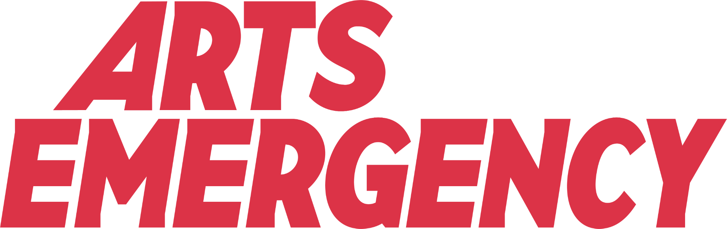

The Arts Emergency Work Experience Pack

Congratulations on your work experience placement! Work experience is an amazing way of getting valuable insight into a job and making your first contacts in the industry you’re interested in. You’ve earned your place so it’s time to make the most of it. Arts Emergency Young Talent who have been on work experience placements before have ended up being asked back on paid placements. We hope that it is a positive experience for you and we will be here to support you along the way.

You can click on the headings below to go to each section:

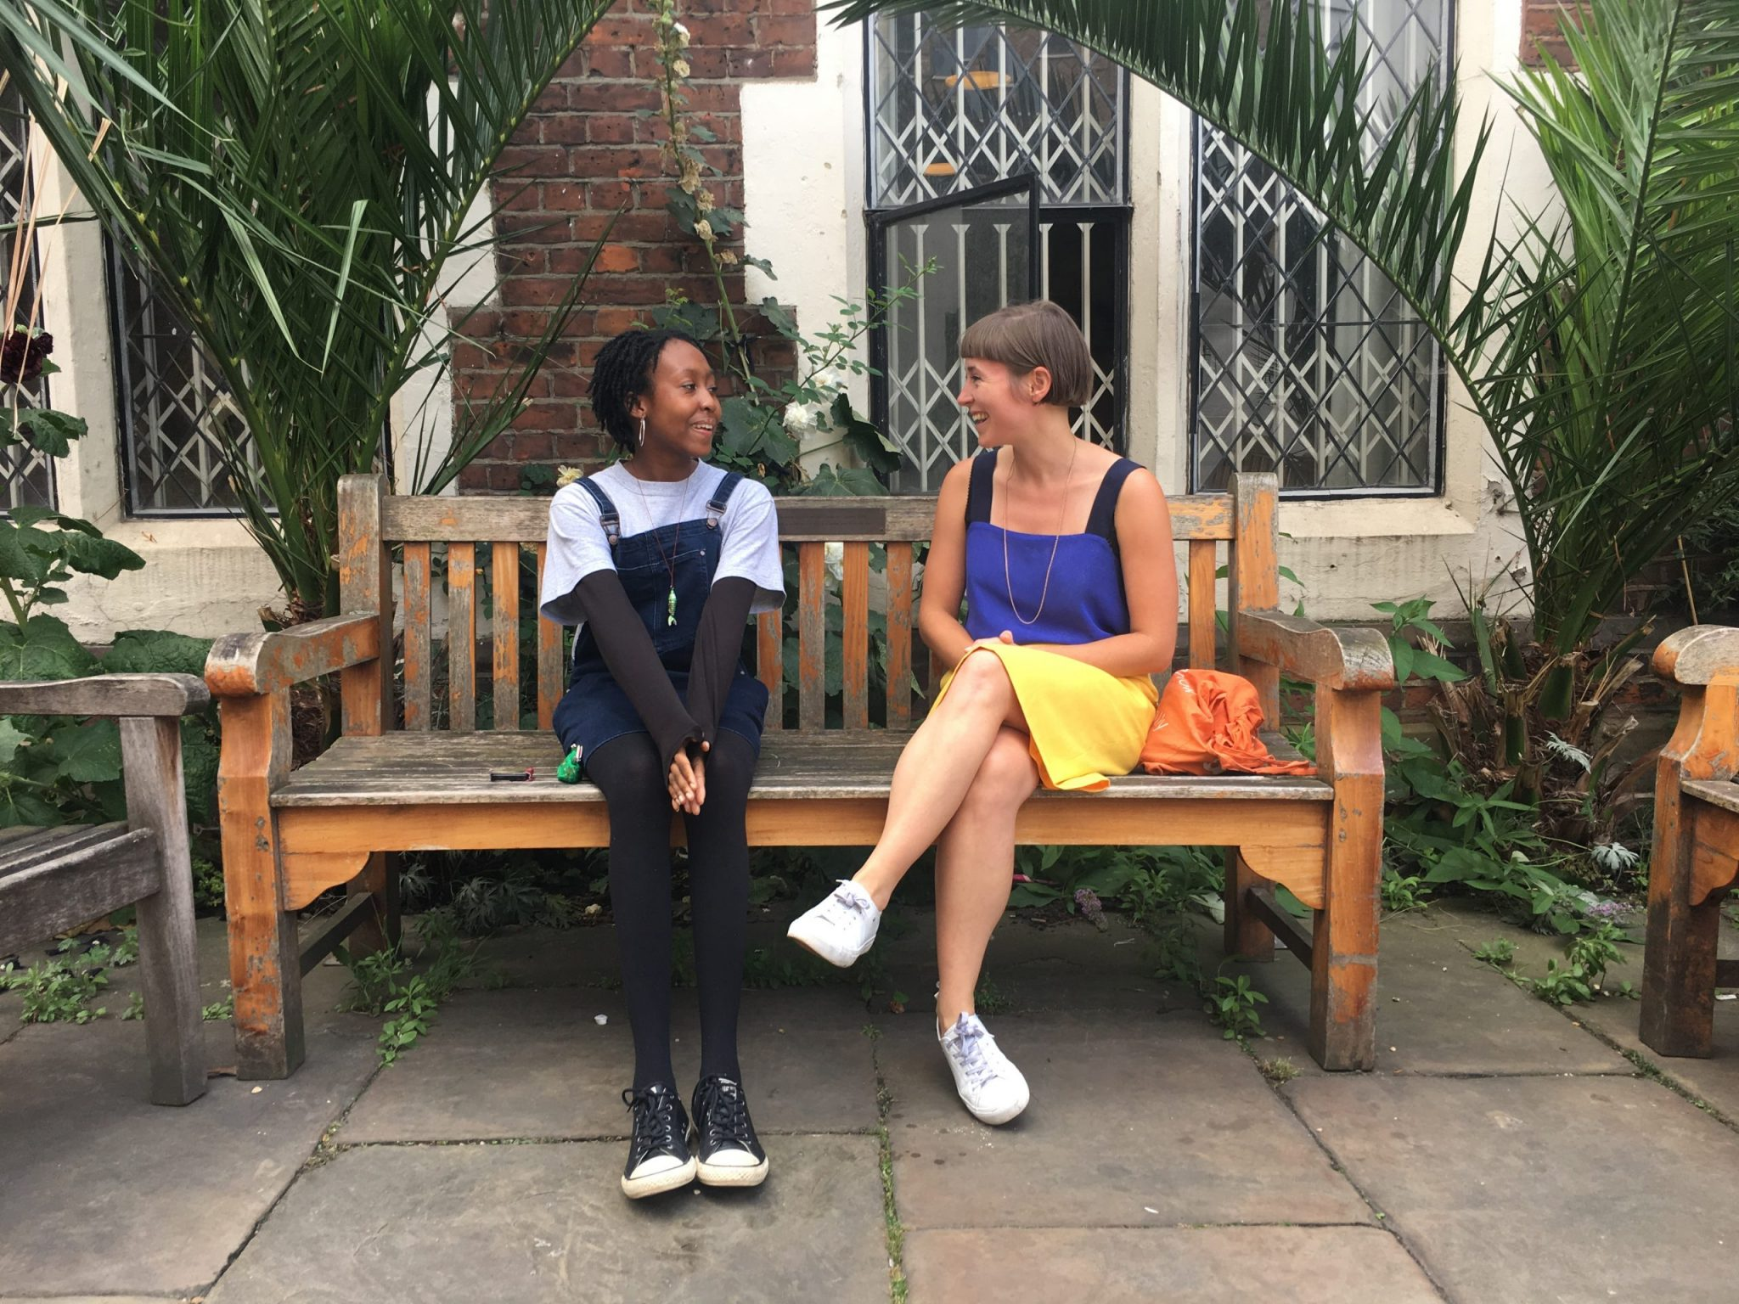
- Information about work experience
- Doing an on-site placement
- Doing an online placement
- Interviews
- Before you start
- During work experience
- On the last day

Mahalia and Katie at ArtsAdmin

Information about work experience
Length and hours

- Work experience runs for 5 working days, usually Monday to Friday.

- The organisation should not ask you to work for more than 5 days unpaid - if they ask you to work longer, let us know.

- The organisation should not ask you to work longer than 7 hours a day - if they ask you to work longer, let us know.

- The organisation should give you at least 45 minutes for lunch. If they are not doing this let us know.

Your contact at the organisation

- You will have a lead contact at the organisation you’re doing work experience at who you will meet at interview. They will assign you tasks and be the person to go to if you have any questions or concerns.

- Making a good impression on this person is very important because they will be the one writing you a reference at the end of the week. Make sure you are being professional and polite at all times.

Expectations and tasks

- You will be expected to attend every day of work experience. If for some reason you can’t do this, you must let Arts Emergency and your lead contact know well in advance.

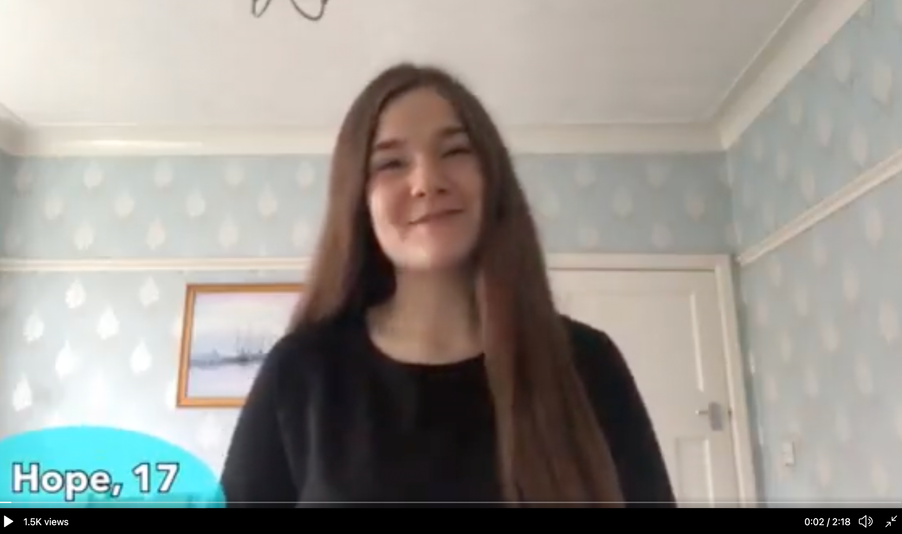
- Depending on what the organisation does, you might be doing anything from researching, helping with admin, recording a video, reading scripts, writing a blog or making a presentation. Check out this article written by Jaya during her placement at the Times Educational Supplement and watch Hope’s video diary made for Mountview Theatre Academy for more on what to expect.

- You will be representing yourself as well as Arts Emergency. Making a good impression counts! This means being respectful, kind and curious.

- During your placement, you should feel welcome, supported, and respected. If you feel like you are being treated unfairly or discriminated against because of your faith, gender, race, age, sexuality or disability you must let us know. If you feel unsafe or uncomfortable at any time get in touch with us and we will talk through it together.

Doing an on-site placement

An on-site placement means you will be going into the office every day! Here are some tips for your in person placement.
Getting there: It’s important that you turn up to your placement on time. Aim to get there 15 minutes early on your first day. You might want to do a practice journey so you know exactly where you’re going and don’t meet any surprises along the way.
Facilities: Make sure you ask where the toilets, kitchens and faith rooms are located. If you have access needs please let the organisation know in advance.

What to wear: As you’re going into the office, it’s best to dress formally. Check with your lead contact what the dress code is! If you are doing a practical placement you may need to wear covered shoes and protective clothing.
Expenses: You will be given money to cover your lunch and travel expenses. If you don’t receive this, let us know.
Covid-19: On-site placements will only go ahead if government guidelines allow. Remember to stay safe and keep others safe. That means washing your hands regularly, wearing a mask in public spaces and cleaning shared surfaces thoroughly.

Doing an online placement

An online placement means you will be working from home! This is something a lot of people are doing because of Covid-19. You will be working mostly on a computer, laptop or tablet and will need regular access to the internet. If this is difficult for you, let us know .
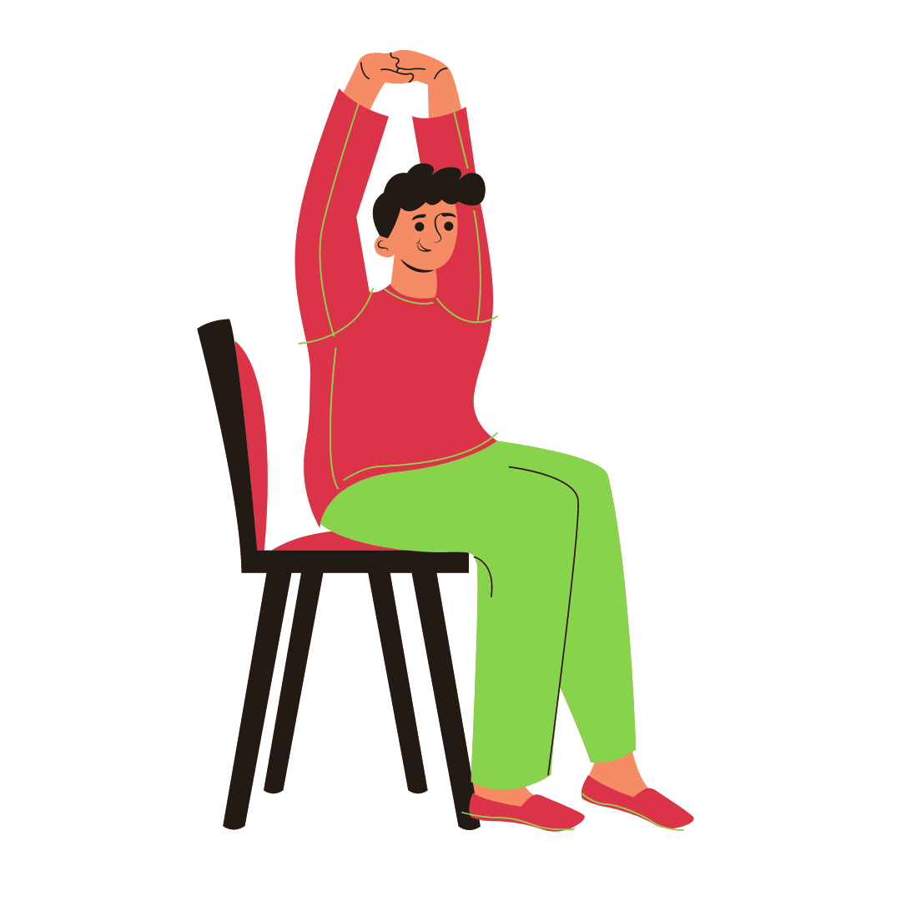
Working from home: Working on your laptop for long hours can be a bit tiring on your body. Make sure you are taking short breaks away from your screen, getting fresh air and stretching!

Online platforms: Common online video/chat platforms are Zoom, Skype, Slack, Microsoft Teams and Google Meet. If you are unfamiliar with the platform your lead contact is using, make sure you ask them to explain how it works.
Video calls: It’s best to have your video on during work placement meetings but ask your lead contact about their organisation’s video call etiquette. Make sure you are somewhere quiet, if possible, and have a neutral background. Use headphones if you can to reduce background noise. If you don’t have headphones, let us know .
Wifi: You will need regular and good access to the internet. If your wifi is playing up, you can share your mobile number with the organisation so you can communicate over the phone instead. Please let us know you are doing this.
Communication: Working from home means that communication is so much more important. Be considerate of your lead contact’s time and make sure you are available when agreed. If you have questions, be brave and ask!

Interviews
You will be introduced to the organisation at an informal interview organised by Arts Emergency. This will be a chance for you to meet them and ask any burning questions! Your interview will be over video call so here’s what to expect.
What we will ask you:
- your name and pronouns
- what you’re up to
- why you applied for the placement
- what your goals are for the placement

What you might want to ask them:
- what is the dress code for your organisation?
- what will my working hours be like?
- what does a normal working day look like for you?
- what will I be doing during the placement?
- is there anything I should do to prepare for the week?
- how do you think I can make the most out of the week?

Before you start work experience

It’s totally natural to feel a bit nervous, so here are some tips to help you feel prepared.

Research the organisation

- Google is your friend (kind of!) Find out as much as you can about the organisation before you start to give you an insight into their work.

- Make notes of things that interest you and things you would like to find out more about. For example:
  - “What types of projects have your organisation worked on before?”
  - “What do you usually look for in an employee?”
  - “How has your company had to adapt since lockdown?”
  - “What skills do you think you need for this job”

Answer these questions here or in a notebook:

- What skills do I already have?

- What skills do I want to develop?

- What do I feel uncomfortable about?

- What can I do to help with this?

- What questions do I want to ask?

- What are my goals for this placement?
To find out

To develop my

To have had experience with

During work experience

Keep in contact

- Check in with your lead contact every day in person, over video or email.
- Make sure you are responding in good time to their emails - a useful rule is to do anything that takes less than 2 minutes straight away! Remember good communication is key in the workplace.

Double check

- Always double check the tasks you’ve been given and ask if you’re ever unsure. It’s much better to ask than to do it wrong.

No question is a stupid question!

- Your placement will be expecting you to ask questions so don’t be shy and ask away! This should be a learning experience for you.
- Avoid personal questions around sexuality, religion, politics etc. if they are not relevant to your discussion. If you’re ever unsure, check with Arts Emergency first.
- Avoid asking “how much money do you make”, especially on your first day. Instead, you could ask “what’s a normal starting salary in an organisation like yours?” or “what’s the usual freelance rate in this industry?”

Writing emails

- Writing emails can sometimes be tricky.

- You don't need to be overly formal or too casual. Starting your emails with “Hi xxx, how are you?” works well.

- You can end your email with something like “Best wishes, Best or Thank you”

- Avoid one word email responses as it can come across as rude 😬
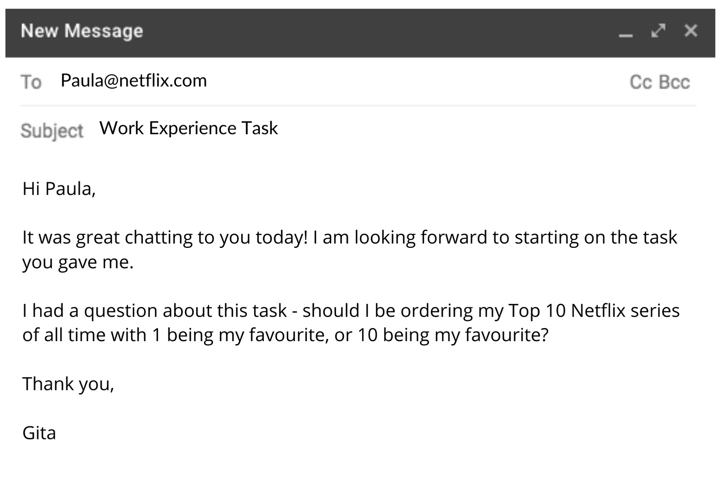

Video calls

It’s completely normal to find video calls uncomfortable but the more you do them the easier they will become. Here are some good things to remember:

- Make a plan for your call and write questions down so you can refer to them during the conversation.

- Make sure you're somewhere quiet if possible.

- If you can, use headphones so there’s no distracting background noise.

- If you’re on a video call, make sure there isn’t anything embarrassing, offensive or private in the background.

- It’s a good idea to have your video on in work placement meetings as it helps new colleagues get to know you. If during the week you would like to keep your video off, let the other people in the meeting know.

Photography, videos and social media

- We LOVE seeing photos and videos from work experience placements! If you feel comfortable, take a picture of yourself or your work at your placement and send it to us at community@arts-emergency.org. We will ask you to fill out a media permissions form before we share it.

- Please do share that you are taking part in an Arts Emergency work placement on social media but try to avoid having your full name on display. First names are great!

- You can add/ follow the organisation on social media but if you are under 18, they are not allowed to follow you back. It’s best to keep communication to email and not via DM.

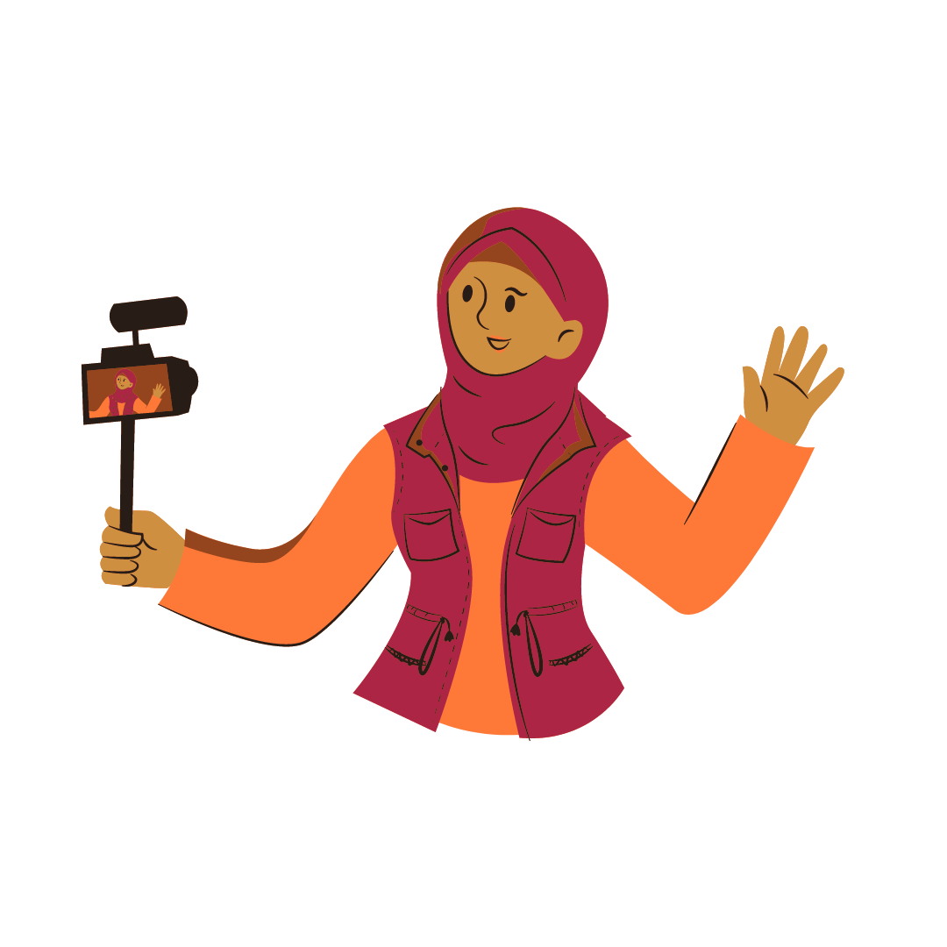

Keeping safe

If at any point during work experience you are made to feel uncomfortable or unsafe let us know straight away. Some of the following might seem quite obvious but it’s very important to bear in mind.
Communication: Try to keep communication via email and video call if you are working from home. If you need to communicate over your personal phone because your internet is bad, let us know.

The working week: The organisation should not be making your work longer than 5 days a week and 7 hours a day. They should not be making you work without a lunch break and should let you take little breaks if you need it. They should not be asking you to work on weekends unless it’s for a site visit, but check with us first!

Personal information: Do not share your home address. The organisation should not be asking you for personal information that makes you feel uncomfortable or is unrelated to work experience. No one should be asking you to send personal or inappropriate photos.
Video calls: Do not secretly record or screenshot during a video call. No one should have anything personal or offensive in the background while on a video. No one should be asking you to undress during a call or do anything that makes you feel uncomfortable.

Your wellbeing: Working lots on the computer can strain your eyes and give headaches. Make sure you are taking lots of little breaks away from your screen. Make sure you are drinking water and staying hydrated. Remember that this should be a positive experience - no one should be making you feel small or undervalued.
Social media: Do not share your social media information with the organisation unless it is a professional account such as LinkedIn or a professional Instagram account.

Remember!

During your placement, you should feel welcome, supported, and respected. If you feel like you are being treated unfairly or discriminated against because of your faith, gender, race, age, sexuality or disability you must let us know. If you feel unsafe or uncomfortable at any time get in touch with us and we will talk through it together.

On the last day

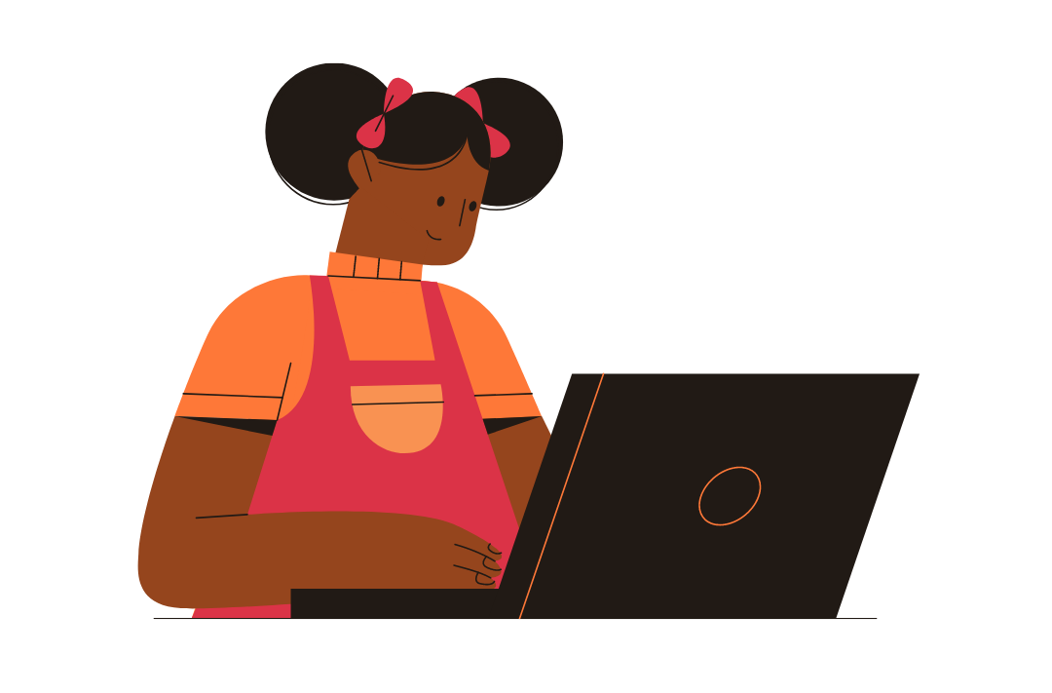
- We will ask you to fill in a reflection report. This is super important and if you don’t do it we will bug you relentlessly about it!

- Ask your lead contact if you can use them for a reference .

- Ask your lead contact for advice on your next steps.

- Send the organisation one thank you email after the placement has ended.

- Adapt your experience for your CV and future personal statements or cover letters.
There are examples below. Canva is a good place to make sleek looking CVs.

