Fundraising Manager
Application Pack
May 2022

About us
Arts Emergency is a mentoring charity and support network. Since 2013, we have worked to address the inequalities in the creative and cultural sectors. Founded in Hackney by two friends, activist Neil Griffiths and comedian Josie Long, we now support 1,300 brilliant young people across the UK. We provide guidance so they can chart their own course. We create connections to help them get ahead.

Our values
• We are bold, actively changing UK culture in a big,
far-reaching way
• We are optimistic about the future and celebrate the best in human nature
• Community is fundamental to our existence and the
success of our mission
Read more about our life-changing work in our Impact Report: https://www.arts-emergency.org/about-us/reports

78% of mentees expanded their network

What we do
Arts Emergency provides 16-25 year olds in London, Greater Manchester, Merseyside and beyond with a trained mentor working in their field of interest. Mentors help Young Talent set goals, explore their passions and make decisions about higher education, training and careers.
After they complete a year of mentoring, Young Talent can continue to access opportunities, advice, resources and paid work from the Arts Emergency Network until they turn 26. The network is made up of thousands of cultural professionals who’ve all offered to share
crucial gateways into hard to crack industries like TV, publishing and architecture with young people underrepresented in those fields. High profile members include comedians Nish Kumar and Sara Pascoe, actors Nikesh Patel and Julie Hesmondhalgh, and writers Neil Gaiman and Sarah Perry.

“Arts Emergency has done more for me than I ever thought possible, it has opened doors I thought were closed. It has given me hope.”
Deji, Young Talent

Find out what our mentors and mentees have to say about us: https://www.youtube.com/watch?v=YfGpqEFQfO4&list=UUDgi0ANbxM0t8aKSpxgjdpg&index=12

Our plans for the future
Our vision is of a society where every young person gets a fair chance to flourish and every opportunity to contribute to the culture in which they live.

This is an exciting time to join Arts Emergency and help to shape the future of the organisation. In Spring 2022, we are conducting a strategic review to inform our direction and update our mission and impact. This year we are also recruiting four new board members to help us achieve this and welcoming a new Youth Collective, who’ll ensure that young people’s voices are amplified through our work.

This is a critical time as we expand nationally to meet the urgent need for our support. Having grown five-fold since 2016, we’re aiming to work with up to 2,000 young people by 2024/25. We’ve identified ten priority areas across the UK that meet a combination of eligibility and viability criteria for new projects.

Our Community programme is also growing to support our Young Talent with their career progression and personal development. We will enhance our work experience and paid work opportunities in partnership with creative and cultural organisations, and offer each young adult on our programme tailored CV, interview and employability support.

Read more about our plans in our Vision document: https://www.arts-emergency.org/files/policies-and-guidance/2019Vision-Doc.pdf

Our team

The Arts Emergency team is a group of passionate and dedicated staff and trustees who bring together a wealth of experience from the charity and cultural sectors.

“I am thrilled to be part of the hugely important changes Arts Emergency is making to the industry and its legacy that has affected so many for the better, in such a short time.”
Yomi Adegoke - Writer, Journalist, and Board Member

Meet our team: https://www.arts-emergency.org/about-us/our-people

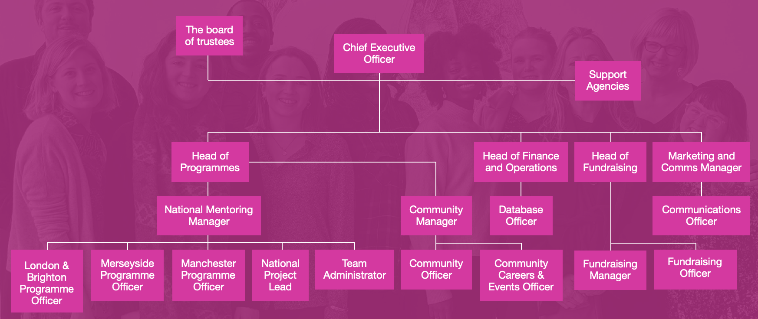

Commitment to equality and diversity

Arts Emergency is committed to being a welcoming and inclusive organisation. We’re dedicated to social justice and making the arts and humanities equitable for all. We help our volunteers to address the structural inequalities in the cultural and creative industries, and use our voice to influence gatekeepers to make real, long-term changes. When we recruit we will always: show the salary, pay a living wage, and won’t demand a degree as an essential criteria (unless a specific qualification is required for a role). We particularly welcome applications from disabled people, LGBTQIA+ people, Black, Asian and minority ethnic candidates.

“Our future cultural landscape is in danger of being populated exclusively by the children of the wealthy and well connected. I love Arts Emergency because it works to bridge this gap. To create the opportunities that have been taken away”
Julie Hesmondhalgh, Actor

We are committed to the employment and development of disabled people. We guarantee to interview anyone with a disability whose application meets the person specification for a post. To be invited to interview, you must show in your application that you meet the person specification for the role. If you tell us that you have a disability we can make reasonable adjustments to the interview process, and, if you join us, to your work arrangements. If you’d like to discuss any access needs or adjustments please get in touch.

Fundraising Manager

Permanent, full-time
Monday to Friday
£30,000

As Fundraising Manager, you will be responsible for managing and growing Arts Emergency’s income from trust and foundations. You will also contribute to the overall fundraising strategy and objectives of the team.

This is an exciting new position within a fundraising team of three including a part-time Fundraising Officer and full-time Head of Fundraising. The charity has grown rapidly in the last four years and continues to plan for sustainable growth in the next three.

You’ll get to work with a portfolio of 11 current funders, detailed pipeline of potential funders (refreshed in Spring 2022), and the outcomes from an organisation-wide strategic review that will be completed in June 2022 and provide Arts Emergency with a refreshed mission, theory of change and evaluation framework.

The appointee will have the choice to work remotely, from the London or Manchester office, or a hybrid of both. Our working week is 35 hours. Some evening and weekend work may be required for which time off in lieu will be organised.

Key tasks
• Alongside Head of Fundraising, contribute to and deliver a sustainable fundraising strategy for trusts and foundations.
• Steward and engage our existing trust and foundation funders.
• Write high quality reports and thank you letters.
• Grow our portfolio of trust and foundations, working to agreed income targets.
• Create compelling, emotionally powerful funding applications complete with budgets, costings and financial data as appropriate.
• Work collaboratively with colleagues in the Programmes team to understand current projects and identify areas of activity for funding.
• Build on a pipeline of potential funders and conduct detailed, ongoing research into new funding opportunities and prospective supporters.
• Record all activity on the organisation’s database, Salesforce.
• Champion the fundraising team’s use and maximisation of Salesforce, with the support of the Database Officer.
• Take responsibility for certain projects within corporate and individuals fundraising, as identified with Head of Fundraising.
• Play a full and active role in supporting the Head of Fundraising to meet ambitious income targets.
• Complete all work in accordance with current fundraising and data legislation, working towards best practice at all times.
• Support the team when required by attending and helping organise occasional fundraising events.
• Maintain our ethos and values, and positively promote our work and activities at all times.
• Undertake any task that may be requested from time to time that may be consistent with the nature and scope of this post.

Key results and objectives
• Network of funders are appropriately engaged and mobilised to further strategic aims.
• Achieve annual income targets set for grant fundraising (c. £200,000).
• A pipeline and reporting schedule is in place and in process for applications and approaches.
Person specification

Skills/competencies
• Capability in Microsoft Office programs.
• Capability when using databases e.g. Salesforce.
• Good administrative and organisational skills.
• Excellent writing skills and the ability to communicate clearly and emotively.
• Excellent numeracy and budgeting skills.
• Good attention to detail and ability to proofread.
• Time management skills – the ability to work to deadlines, and under pressure, balancing several priorities at once.

Knowledge
• Trust and foundation landscape (arts and culture, social justice, youth, education).
• Understanding of national youth charity landscape.

Previous experience
• Experience of grant fundraising and writing high quality applications.
• Proven track record of securing revenue and project funding from large and medium-sized grant-giving organisations.

Special attributes
• Up-to-date knowledge and interest in culture.
• A demonstrable passion for social justice and/or diversity and inclusion work.

Personal qualities
• A commitment to upholding our values of being bold, optimistic and community-led.
• Passionate and driven to make a positive impact on the world.
• Always learning: a self-starter, motivated, eager to learn.
• Resourceful and embraces challenge and change.
• You will need to have the discipline to work independently and communicate proactively with the wider team.

How to apply
To apply, please visit the Ashby Jenkins website:
https://www.ashbyjenkinsrecruitment.co.uk/job/fundraising-manager-trusts-and-foundations-work-from-anywhere/

As part of your application, you will be asked to supply a CV, a cover letter showcasing your experience and interest in the role, and complete an Equality and Diversity Monitoring survey.*

If you would like to have an informal discussion, or have any questions about the application process or the role, please call Christina on 02030062787 or email info@ashbyjenkinsrecruitment.co.uk.

Please submit your application by 10am on 13 June 2022.

Interviews will take place between 16 and 22 June.

Please see our privacy policy to find out more about how we handle your data.

*The survey is anonymous and not linked in any way to your application. Any information you provide will be used by Arts Emergency to monitor the demographics of candidates applying for roles and make improvements in line with our diversity and inclusion ambitions. This data will be treated in accordance with the General Data Protection Regulation 2018.

Contact us

+44 (0)20 7683 1077
jobs@arts-emergency.org
www.arts-emergency.org

Arts Emergency
Unit W3
8 Woodberry Down
London
N4 2TG

Registered Charity Number 1152377

